An Chloch Bhán
C.L.G.

(Cloughbawn GAA Club)

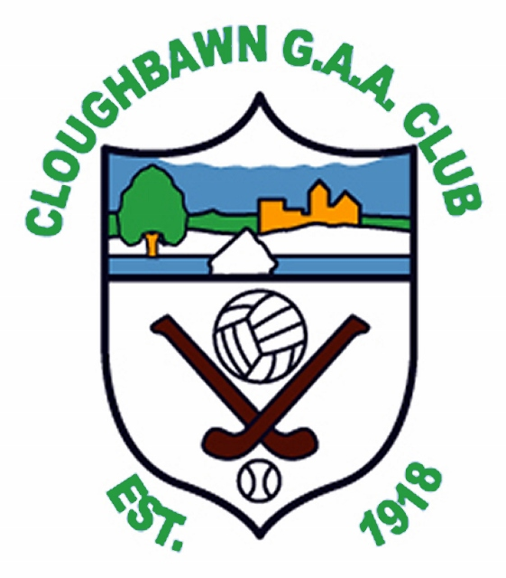

5 Year Development Plan
2013 – 2017

Coaching and Games Development

In five years (2018), we will be able to say:
“Cloughbawn GAA and Camogie Club is providing a consistently high standard of Coaching from Nursery to Adult level. The aim of each coach is to make a player better than even that player thought they could be. The appropriate emphasis on skill and success is being applied at the correct age levels and the club is enjoying success at adult level as a result”

KEY PROJECTS

- Appoint Club Coaching Officer & Coaching and Games Development Sub-Committee (C&GDC)
We will appoint a Club Coaching Officer, who will be chairman of the Coaching and Games Sub-committee. He/She will have responsibility for managing the affairs of the committee and for overseeing all coaching and games related activities and policies
We will appoint a Coaching and Games Development Sub-Committee to oversee all aspects of games development in the Club and to ensure this Development Plan is implemented in the spirit in which it was intended. This will include identifying new coaches in the community, encouraging parents to become involved in coaching and ensuring that all our Clubs coaches have GAA Coach Education qualifications. The committee will also ensure that a balanced programme of games is in place and that all players get an opportunity to play and participate. The Sub Committee should consist of not less than 5 people with at least one active coach each from Coiste na nOg, Camogie and Adult Club.
This committee should meet regularly to ensure standards are maintained.
- Improve Coach Education/Standards
The C&GDC put in place a programme that makes sure that all Club coaches will receive GAA coach education qualifications. Each coach should have a minimum of a Foundation Award coaching certificate by the beginning of the 2015 playing season. We will aim to have all coaches at Award 1 level over time.
The C&GDC will also arrange for regular coaching education courses to be provided by expert coaches from both outside and within the Club.
The C&GDC will also ensure that all coaching members are informed of any other Coaching workshops etc being run in the locality
- Club Coaching Manual
A Coaching Manual to be produced from the various different resources into one easy to follow guide. The purpose of the Manual is to assist new and experienced Coaches and not to impose on them how they should run every coaching session. The manual will determine the Bench Marks for each age category with regard to what level of skill should be attained.
At the forefront of the Manual will be the Club ethos – Hard work and Discipline.
- GAA Code of Best Practice and Code of Behaviour
The C&GDC will support the GAA Code of Best Practice and Code of Behaviour. Everyone in the Club will show due respect to each other, to Club officers, to team mentors, opponents and to the match officials. We will ensure that all our volunteers working with children are Garda vetted and that our children participate in a safe environment.
- Club/School Link
We will develop close links with our local primary schools in St Josephs, Donard and St Aidans, Clonroche. A School Liaison Officer to be appointed by the C&GDC who will work with both schools to ensure they are receiving the correct level of coaching and also to organise additional coaching from Club members to complement the coaching being afforded by the Wexford County Board.
The School Liaison Officer will also organize the production of ‘Skill Sheets’ to be sent home through the schools to make it easier for parents to coach their own children in the home.

- Establish Club Nursery Programme
The C&GDC will conduct a study to examine the merits of establishing a GAA Nursery Programme within the club to cater for 4-6 years olds.
The purpose would be to develop players at a younger age concentrating on technical movement and balance in a non competitive fun environment to take the pressure off the U8 Managers. The C&GDC will examine possible playing numbers and visit other clubs who have such a programme in place to determine best practices.

- Cul Camp/Training Camps
The C&GDC will actively promote Cul Camps in the locality and examine the possibility of running a Camp on Cloughbawn Grounds (under the Cul Camp umbrella subject to ratification by Wexford County Board Games Development Committee) to develop and promote GAA skills in a fun and supervised environment.

Action | Outcome Sought | Timescale | Milestones | Responsibility
Club Coaching Officer and Coaching and Games Sub-Committee Appointed by the Club Executive Committee | To oversee all aspects of games development in the Club and ensure the best possible coaching structures are in place in our Club | June 2013 | Establishment of C&GDC and verification by executive committee | Club Executive Committee
Produce a Club Training Module | To assist coaches in organising effective training sessions | Feb 2014 | Production of Manual to be available to all new and existing coaches prior to start of 2014 season | Coaching and Games Committee
Club-School link in place.  Club-School liaison officer appointed | To cement the relationship between the local schools and the Club and ensure that the children are receiving GAA coaching.  In addition to the Coaching being offered in the schools by the County Board, the Club will complement these, also during school hours using current club coaches as well as current and former players. | September 2013 | School Liaison Officer actively in place and a programme implemented whereby Cloughbawn coaches would attend local schools regularly . | Coaching and Games Committee
Examine the possibility and advantages of setting up a Nursery programme in place for 4 to 6 year olds | To encourage our young players to become involved in Gaelic Games in a fun and safe environment | Report by June 2014 for possible implementation in 2015 season. | Completion of study and implementation of programme. | Coaching and Games Committee
To encourage more parents to become coaches | To increase the number of coaches available to our Clubs | Ongoing | More parental involvement particularly with younger age groups | Coaching and Games Committee
All Club coaches receive GAA Coach Education and have access to coaching resources (www.gaa.ie) | To ensure that our coaches are trained to the best possible standards | Ongoing | An increase in the number of coaches attending training courses each year. | Coaching and Games Committee
Cύl Camp promoted each year supported by our own Club coaches | To give all children in the locality the opportunity to be coached in Gaelic Games | Ongoing | Good take up on local Cúl Camp places by Cloughbawn players | Coaching and Games Committee
GAA Code of Best Practice and Code of Behaviour in place | To promote an environment of respect in the Club and to ensure that all children participate in a safe environment | Ongoing | Evidenced by greater respect shown by all players, mentors, parents and supporters | Children’s Officer
All coaches working with underage players attend Child Protection Workshop | To ensure that all children participate in a safe environment | Ongoing | All active coaches will have attended course | Children’s Officer
All coaches working with underage players have received Garda Vetting | To ensure that all children participate in a safe environment | Ongoing | All active coaches have up to date Garda Vetting | Children’s Officer

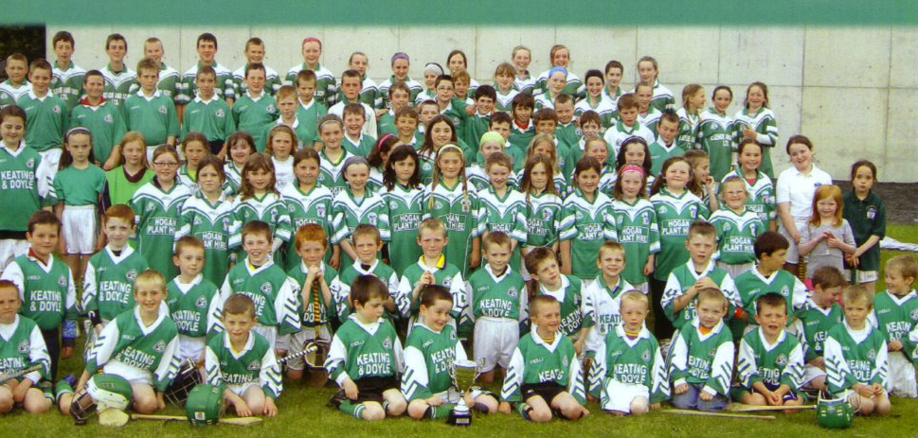
Club Structures & Administration

In five years, we will be able to say:
“Clougbawn GAA club excels in its administration. We have the structures in place appropriate to the Clubs needs. Our Club Executive is vibrant and we have increased the number of people volunteering in the Club.”

KEY PROJECTS
- Club Constitution
Ensuring club constitution as per Croke Park latest version is adopted, updated and in place. Amend to include Camogie Club and Coiste na nÓg representation and adoption of ‘One Club Concept’. All Club motions passed at AGMs over the last 10 years to be appended and total package approved by Cloughbawn Executive Committee and by Wexford Co Board when amended.

- Sub-committees
We will continue to appoint sub-committees to deal with club Finances, Coaching & Games Development,, Facilities & Development, PR/Communications/Culture, Membership, Discipline, Sponsorships and other areas as deemed necessary. We will recruit new volunteers to sit on these committees who have a particular talent for these areas.
We will also appoint a Club Plan Implementation Sub - Committee to monitor the club plan. This committee will include the Club Chairman, Club Secretary, Club Treasurer, Club PRO and Club Coaching Officer as well as others as required.
- Volunteer Recruitment
Follow the GAA volunteer Recruitment Toolkit for Best Practice in Recruiting so that the Club is following best practice in terms of recruiting and retaining volunteers (www.gaa.ie)

- Club Officers Advice Manual
Encourage use of GAA Online Club Advice Manual for Club Officers (www.gaa.ie/clubzone/club-manual/)

- Club Alcohol And Substance Abuse Policy
Our Club Alcohol and Substance Abuse policy will be promoted to make sure that our Club is following best practice regarding the use and/or abuse of alcohol or drugs in the Club. All juvenile medal ceremonies will take place in an alcohol free environment. Club Alcohol And Substance Abuse Policy to be updated and Officer training be up to date
- Vesting Documents And Club Trustees
Ensure all club vesting documents are in order and club trustees are up to date to safeguard all of the Clubs property

- Children’s Officer
Ensure club children’s officer is active and training up to date, to oversee implementation of the GAA Code of Best Practice and to deal with any allegations of abuse in the correct manner.

- Membership And Player Details Up to date.
All teams affiliated to the Player Injury Fund. Accurate membership and player details to be updated on Servasport website - to comply with GAA regulations on registration of players and members.

Action | Outcome Sought | Timescale | Milestones | Responsibility
Ensure club constitution  Is updated, adopted  and in place. | To have current Club Constitution in place.  Amend Constitution to include Camogie Club & Coiste na nÓg representation and adoption of ‘One Club Concept’. | June 2013  AGM 2013 | Constiution updated.  AGM 2013 | Exec Ctee.
Appoint sub-committees to deal with club Finances, Coaching, PR, Discipline, Membership, etc......  Plan Implementation Sub-Cttee formed to monitor club plan.  Include Camogie and Coiste na nÓg reps on executive committee. | Delegate workloads to sub committees. Clarify roles of committees. We will recruit new volunteers to sit on these committees who have particular a talent for these areas.  Club plan is a live document and a dedicated committee to be formed to ensure we are continuing to meet our declared targets.  Include Camogie & Under Age as ‘One Club Structure’ in Cloughbawn GAA Club. With reps on Exec Cttee and on designated sub cttees e.g. Finance/Fundraising, Coaching, Membership, Discipline.......... | After AGM a.s.a.p. each year.  June 2013  AGM 2013. | Sub Cttees formed.  Monthly meetings  AGM 2013 | Exec Cttee.  Exec Cttee
Follow the GAA volunteer recruitment toolkit for best practice in recruiting (www.gaa.ie) | Recruitment policy of club in line with best practice in GAA in terms of recruiting and retaining volunteers  New volunteers for committees – parents of younger players | Ongoing | Ongoing | Exec Cttee
Encourage use of GAA on-line Club advice manual for club officers (www.gaa.ie/clubzone/club-manual/) | Best Practice sought. More relevant info for new officers/roles requirements in Admin. | Ongoing | Ongoing | PR/Communications/Culture Cttee.
Club alcohol and substance abuse policy to be updated and officer training be up to date | Policy updated on ongoing basis. | May 2013 | Ongoing -and after reported incidents. | A.S.A.P. Officer & Cttee.
Ensure all club vesting documents are in order and club trustees are up to date | Club vesting docs up to date and secured. To safeguard all of the Clubs property | May 2013 | Any change in trustee personnel, property | Exec Cttee/ Chairperson/ Secretary
Ensure club children’s officer is active and training is up to date.  Vetting up to date. | To oversee implementation of the GAA Code of Best Practice and to deal with any allegations of abuse in the correct manner.  All managers/mentors vetted. | May 2013  May 2013 | Annually.On-going.  Annually and ongoing. | Children’s Officer.  &  Chairperson.  Vetting Officer  (Sgt. B.Cooper)
Membership and Player details to be updated on Servasport Website. All teams affiliated to the Player Injury Fund. | Accurate and up to date information details of members and players. To comply with GAA regulations on registration of players and members. | July 2013 | New Recruits. Ongoing – every new year. | Secretary & Treasurer
Promote attendance at monthly meetings – make it all inclusive – change name to ‘monthly member meetings’ and not just for executive | Improved attendances at club monthly meetings | June 2013 | Newsletters, Website, FB, Papers etc. | PR/Comm/Culture Cttee
Increase concept of ownership to general community | Improved perception of club within the community | June 2013 | Newsletters, Website, FB, Papers etc. | PR/Comm/Culture Cttee
Encourage more players to get involved in club administration | Spread the workload throughout the club members | AGMs 2013-17 | Newsletters, Website, FB, Papers etc. | PR/Comm/Culture Cttee
Encourage new volunteers – social | Non players need outlet to express their support of club. | Ongoing | Newsletters, Website, FB, Papers etc. | PR/Comm/Culture Cttee
Ask people to act as assistants | Help with workloads of club officers. | Oct 2013 | Pre AGMs | Exec Cttee
Improve AGM awareness to encourage larger attendance | Greater attendance at AGM. | Oct 2013 | Newsletters, Website, FB, Papers etc. | PR/Comm/Culture Cttee
Have a centralised database. | Establish ease of access to club information for Club Officers, Mentors & Supporters. | 2014 -2015 | Website, Filing System. Archives. Library, | Exec Cttee  PR/Comm Cttee
WHAT SHOULD WE KEEP DOING?  Compulsory 5 year officer rotation? 3 year? Should look at this before AGM, discuss pro/cons and propose to amend if necessary. | Discuss pros and cons of this max term regulation and formulate motion for AGM to amend if thought beneficial to abolish or reduce officer max term. | PRE-AGM 2013 | AGM 2013 | Exec Cttee
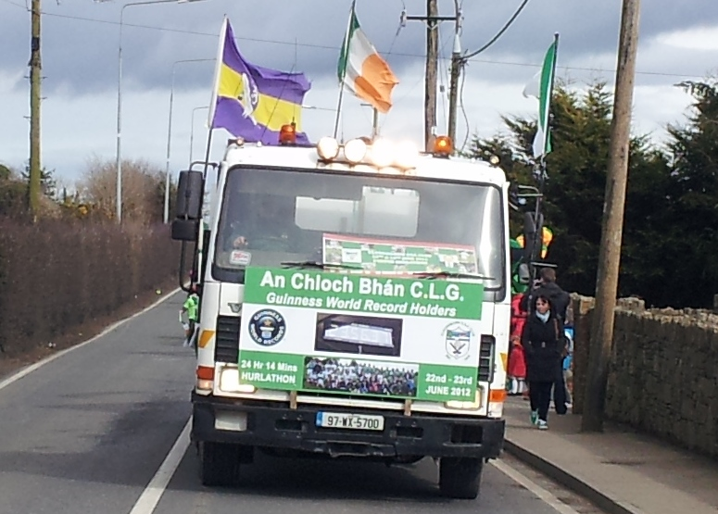

Finance and Fundraising

Our aim: To ensure the expenditure of the club is controlled and funds are in place to meet this expenditure need.

In five years (2018), we will be able to say:
“Our Club is successful in fundraising and in financial excellence in order to support the continued development of our club. We have new and innovative fundraising ideas and have new people helping in the fundraising efforts”

Given the current economic climate it is important the club has a financial plan to ensure the club run its day to day business and plan to implement the various actions outlined in the five year plan. This will include budgeting for day-to-day club expenditure, management of current debts and where possible plan funding for the future development of our facilities through fundraising activity. The responsibility for all clubs financing lies with the Finance Committee. It will appoint a fundraising committee to raise the necessary funds. We will ensure the club complies with the highest accounting and financial regulatory standards. We do this by ensuring that we: Have appropriate financial controls in place; Always get value for money; Protect our assets; Have appropriate resources to achieve our aims; Have clear line of responsibility and accountability throughout the club.

The role of the finance committee is to advise the executive on all financial matters over the duration of the 5 year plan and beyond. Organizing any sort of fundraising event takes up a large amount of time. We will now try to pool resources from all units that form the club when organising large fundraising events. This will maximize our return for the time input. The finance committee shall be responsible for all funds raised. Furthermore the finance and fundraising committee shall grant approval for all fundraising events.

All functions/fundraisers must be advised to the Finance Committee through the Club Treasurer and monies raised lodged with the club. The Finance Committee will be responsible for allocating the monies to the appropriate units and /or teams.

KEY PROJECTS

- Finance Committee
Establish a Finance Committee to monitor and oversee the budget and expenditure. When required, establish specific committees to raise funds for special projects. e.g. Car park upgrade, each of which report to the finance committee. Plan of fundraising initiatives in place each year.

- Budgets
Club Budgets in place. Each unit i.e. GAA, Coiste na nÓg and Camogie shall submit budgets at first executive monthly meeting for the year.

- Accounts Audit
Club accounts audited each year pre-AGM to ensure best practice is followed.

- Advise Executive Committee.
To advise the Executive Committee on all financial matters and arrangements

- Membership
Ensure all people involved in the club are fully paid up members of the club

- Payments Online
Set up payments online for all club payments i.e. Membership, Model Co., Merchandise etc.

- Club Lotto

Consider and implement new ideas on improving our fortnightly Lotto

- Merchandise: Aim to improve Merchandise sales
Action | Outcome Sought | Timescale | Milestones | Responsibility
Establish a Finance Committee to monitor and oversee the budget and expenditure | Financial oversight in place | Annually | When Finance Committee apponted | Executive Committee
General fundraising committee to identify initiatives that will raise the required funds on on-going basis. This should include Sponsorship, Pitch, Model Co. draw, Promotion of Lotto etc. | Plan of initiatives in place each year | Annually | When Finance Committee appointed | Finance Committee
When required, establish specific committees to raise funds for special projects. E.g. Car park upgrade, each of which report to the finance committee | Fundraising committees are appointed as required | Annually | When Special Project targetted. | Finance Committee
Club Budgets in place | To determine the budget and expenditure of the club on an annual basis. | Annually | First Monthly meeting after AGM. | Finance Committee
Club Accounts audited each year pre-AGM. | To ensure best practice is followed | Annually Pre-AGM | Pre-AGM | Treasurer
Each unit i.e. GAA club, Coiste na nÓg and Camogie shall submit budgets at first executive monthly meeting for the year | Financial oversight | Annually | First Monthly meeting after AGM | Treasurers
To advise the Executive Committee on all financial matters and arrangements | Financial Awareness | Monthly meeting |  | Treasurer
To ensure that all membership is paid by 31st March each year | All people involved in the club are fully paid up members of the club | Annually | End March Annually | Finance / Membership Committee
To set up payment online for all club payments i.e. Membership, Model Co., Merchandise etc. | More efficient, convenient method of payment | Pre AGM 2014 |  | Finance Committee
To consider and implement new ideas on improving our fortnightly Lotto | To revive and improve our main fundraiser | On-Going |  | Finance/Lotto Committee
To improve merchandise sales and the wearing of club logo | To make annual profit from Merchandise sales | AGM 2014 |  | Finance Committee
Facilities and Development
In five years (2018), we will be able to say:
“Clougbawn players and members now enjoy the very best possible facilities in the area, both on and off the pitch.”
KEY PROJECTS
- Club Safety Statement
We will update our club safety statement that will help identify all potential safety hazards, thus ensuring that our grounds follow best practice in providing a safe environment for players and supporters.

- Training Area(s) created
Training area(a) required to protect pitches. Location TBC. Possibly lease adjacent land long term? Astro Turf area to be targetted, lights installed.

- Gym established and ready for use next season. Gym needed to help with strength and core conditioning of players.

- Dug Outs Erected.
No dugouts on 2nd pitch yet. Choose design (mobile or fixed) and location (R or L of pitch)

- Pitch Side Advertising.
Advertising boards fitted on Pedestrian Area railings to accomodate Sponsors/Ads.
Steel railings to be extended to protect pitch and will also accommodate advertising. Consider sponsors names on Floodlight Mast Surrounds also.

- Lift Installed.
To facilitate access for all to upstairs kitchen, meeting room, function room. Get quote for Staitlift initially.

- Enclose Electrical Generator compound with cladding (insulated)
To protect major asset from severe icy winters.

- Car Park Areas Surfaced, Entrance & Perimeter Fencing Improvements,
(Tar & Chippings or Tarmac?) Maybe we will decide to choose a combination of both depending on area. Maybe we will choose concrete.
Construct new entrance walls/gates, old tree stumps removed and lane side fence improved/replaced. Car park marked when surfaced.

- Floodlighting equipment.
Generator Serviced annually and Lights Relamped as per guarantee after 10 years. (Due Sept 2017).

- Fit drainage channel & Boot cleaners at front doors
Improve drainage at front doors concrete apron. Install boot cleaners outside front doors.

- Overall Maintenance
Constant mantenance carried out on pitches, walking track, hedges and fences, car parks and grass areas. Also constant maintenance on building fabric, windows, doors, gutters and pathways, while keeping interiors clean, tidy and fit for purpose. Include annual servicing of boiler(s) and generator.

- Install PA System and WiFi. To improve facilities in function room.

- Install Fire Alarm Panel: Comply with Building Regs. Fire Alarm panel installed, Extinguishers located on each floor/hallway, Allocate Fire Assembly point with Signage directions. Introduce Fire Drills.
Reviewed on Tues 16th Sept 2014 (Present were Chairman - Bernard Doran, Sec – Suzanne Keating, Assist Treas - Kathleen Flood, Camogie Chairman - Michael Byrne, Coiste na nÓg Chairman - Mark Codd, Vice Chairman – PJ Dempsey, Tom Furlong)
Action | Outcome Sought | Timescale | Milestones | Responsibility
Club Safety Statement Updated | Providing a safe environment for players and supporters.  (Relocate walking track behind goals) | Apr 2013, Reviewed quarterly.  Winter 2014 | Walkabout required by Chairman & cttee. | Club Executive Committee
Training Area(s) locations selected and created. | Training area(a) required to protect pitches. Location back of goals on old pitch.Can be lit.  Possibly lease adjacent land long term?  Astro Turf area to be targetted, lights installed. | Jan 2014 2015  Jan 2015  Jan 2016 | Sanding & Vertdraining completed.  When Land acquired.  Area Selected for Astro Turf. | Club Executive Committee  and  Development Committee
Gym established and ready for use next season. | Gym needed to help with strength and core conditioning of players. | Nov 2013 | Location agreed | Club Executive Committee
Dug Outs Erected. | Dugouts on 2nd pitch for players/mentors. | Mar 2014 2015 | Design to be confirmed. | Development Committee
Pitch Side Advertising. | Advertising boards fitted on Pedestrian Area railings to accomodate Sponsors/Ads.  Steel railings to be extended to accomodate attendances, to protect pitches from traffic and to facilitate advertising.  Consider sponsors names on Floodlight Lamposts Protection Surrounds also. | Summer 2014 2015  Summer 2014 Spring 2015  Spring 2014 | Material procured.  Availability of labour. | Development Committee
Lift Installed. | To facilitate access for all to upstairs kitchen, meeting room, function room. | Nov 2014  Mar 2015 | Get supplier quotations – at least 2 and expert advice. | Development Committee
Enclose Electrical Generator compound with cladding (insulated)  . | To protect major asset from severe icy winters  Proposed to cover off air vents only for winter icy periods | Sept 2013  Nov 2015 | Material sought from supplier and availability of staff. | Development Committee
Entrance & Perimeter Fencing Improvements,  Car Park Areas Surfaced | Construct new entrance walls/gates, old tree stumps removed and lane side fence improved or replaced.  Car Park spaces marked when surfaced. | 2014/2015  2016/17 | Availability of labour and contractors.  Decision made re surface material. | Development Committee
Floodlighting equipment. | Generator Serviced annually.  Lights fully Relamped as per Musco guarantee after 10 years. (Due Sept 2017) | Annual.  2017 | Keep close eye on guarantee end date. Timely Contact with Musco. | Development Committee
Fit drainage channel & Boot cleaners. | Improve drainage at front doors concrete apron.  Install boot cleaners outside front doors. | Summer 2013 2015 | Get materials and proceed. | Development Committee
General Maintenance | Constant maintenance carried out on pitches, goalposts lifted and painted, portable goals need wheels fitted, goalmouths, walking track, hedges and fences, car parks and grass areas.  Also constant maintenance on building fabric, windows, doors, gutters and pathways, while keeping interiors clean, tidy and fit for purpose.  Improvements in Kitchen/Catering facilities ongoing. Fit under sink water heater.  Include annual servicing of boiler(s) and generator. | Ongoing  Winter 2014  Ongoing  Ongoing  Annual (Dec/Jan) | Monthly meetings | Development Committee
Install Fire Alarm Panel | To Comply with Building Regs - Fire Alarm panel installed, Extinguishers located on each floor/hallway Allocate Fire Assembly point with Signage directions, Establish Fire Drills. | Aug 2013 Jan 2015 | Get quotation and advice on requirements. | Development Committee
Install PA System & WiFi | Improve facilities in function room and modernise communications facilities. | Winter 2013  2015 | Get quotations and advice. | Development Committee

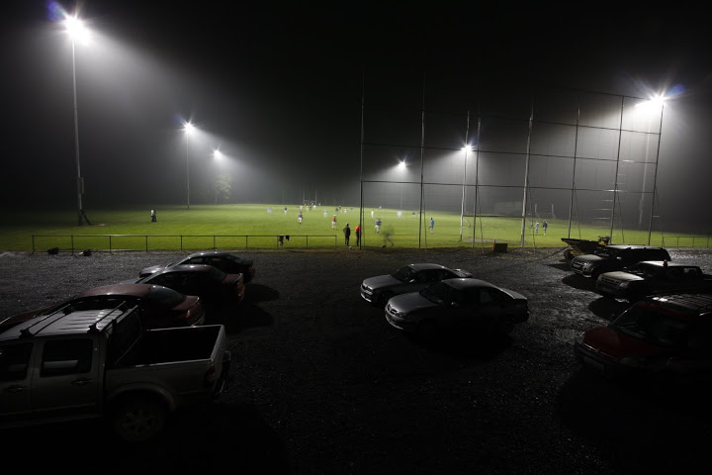
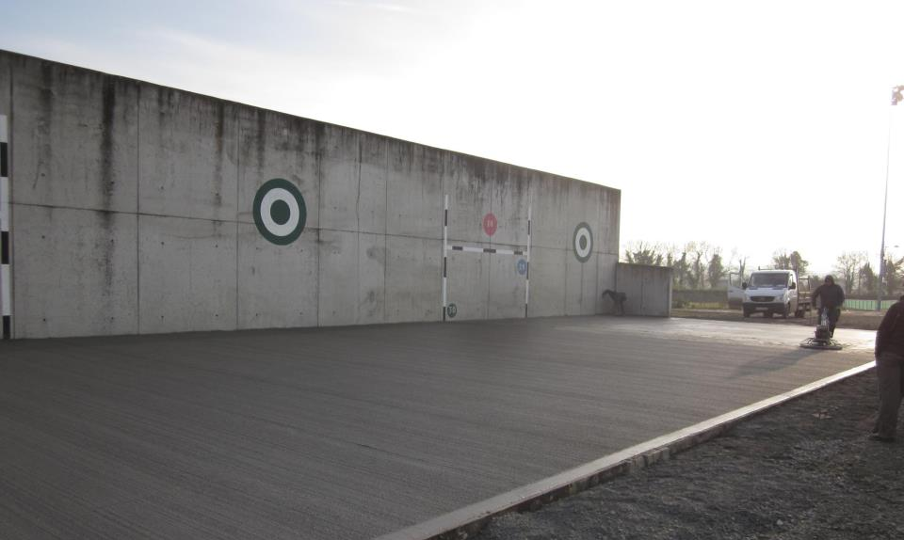
PR/Communications/Culture
In five years time our club will be able to say:

“Our Club is the best possible sporting, cultural and social organisation in our Community. All our members and supporters are connected through traditional and new media. Our members in the community are aware of everything that is happening in the club.

KEY PROJECTS
- Scór
We will enter the local Scór competitions and aim to promote Irish music, song and dancing. This will help encourage people who have no connection with the GAA to become involved in the club.

- Irish Language Promotion
The club will make every effort to promote the use of the Irish language in its day to day activities. This will include the use of the ‘Gaeilge ag an Cruinni’ section in the ‘Culture and Heritage’ section of the online GAA club manual.

- Newsletter
We will email members a periodic newsletter, which will inform them of all of the clubs activities.

- Club on Facebook, Twitter and Website, Use Email & Text.

- NoticeBoard
Erect Notice board at Complex, Clonroche Village and Poulpeasty to facilitate informing community re fixtures, events etc..

- Produce Yearbook

Action | Outcome Sought | Timescale | Milestones | Responsibility
Continue to update our Club website | To have an up to date website that is informative and well presented with input from Camogie & Coiste na nÓg also. | Ongoing |  | PRO
Club Facebook page promoted and  posted to regularly | To help improve communication with our members, particularly with those who are abroad | Ongoing |  | PRO
Continue Weekly Club notes in the local newspaper | To inform the local community about all of the Clubs activities, esp Lotto, Fixtures, Events  Managers to text results to PRO to ensure inclusion in Parish community notes & Newsletter | Information to paper before weekend for inclusion following week. |  | PRO
Publish Club Yearbook | To record all Club activities for the year in one publication in order to raise the image of the Club in the locality | Oct 2013.  Annually |  | PRO
Collect email address and phone number for each Club member | To allow us to communicate directly with all Club members | Ongoing |  | Sec
Periodic newsletter - November - March  Monthly or Bi monthly newsletter - April to October | Newsletter to contain  -Input from Adult Club, Coiste na nÓg and Camogie.  -Articles and input from Clonroche and Poulpeasty School.  -Updates on matches, fixtures etc  -Articles and stories and past events | Aug 2013 |  | PRO
Club to enter Scór competition and promote use of Irish language | To promote Irish music and dance, to attract new people to the Club and to increase the use of our native language | Oct 2013 |  | Culture Officer
Twitter - | Updates re matches - already in place | Ongoing |  | PRO
Notice board on exterior wall of complex with all up coming fixtures | Improve attendances at games and better communications with community.  Also a request for one for Clonroche Village, but we felt that a board would also need to be placed in Poulpeasty | Summer 2013 |  | PRO
Text message service -  Already in place for paid up members | Contact players about training times and matches.  Also available for informing general membership | Ongoing |  | Sec.

 https://sites.google.com/a/gaa.ie/cloughbawn-gaa-wexford/

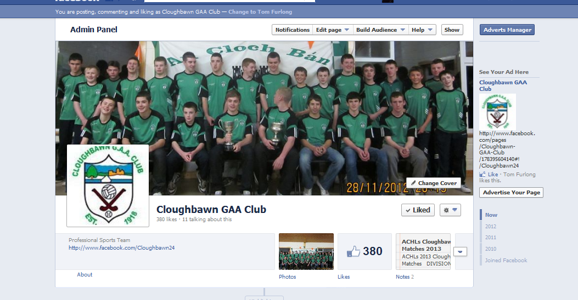
Club Facebook Page

Implementation and Review Mechanisms for the Plan

This Plan is a living document. It will be reviewed, assessed and adapted to ensure it facilitates the Club in reaching its potential over the next five years.

The Club Executive Committee will put in place a Plan Implementation Sub-Committee. This sub-committee will meet on a quarterly basis and assess the progress of the plan against its stated objectives and will report directly to the club Executive Committee.

This team will decide on the most appropriate method to carry out a comprehensive annual review of the Plan. This will involve the assessment of the current initiatives, their appropriateness for the needs of the Club and the identification of additional initiatives to assist in the completion of achieving the goals and objectives.

If required, the Plan will be modified and adapted as required. The Committee will also be responsible for communicating the modified Plan to all Club members.

Acknowledgements
On behalf of Cloughbawn GAA Club, there are so many people that have to be thanked for ensuring the club runs smoothly on a day to day basis and also for putting the plan together.

- Joe Sheehan (Co Board and Clonard GAA Club) for acting as facilitator for the club plan
- The club steering committee for putting the plan in place
- All the people who took time out of their busy lives for taking part in the focus groups
- All Players, Mentors and Volunteers for giving your time and contributing to the successful running of the club
- All club sponsors who have supported the club over the years

